01-134251-049

**AP LAB SEMESTER PROJECT**

GROUP PROJECT

# GROUP MEMBERS

**MUHAMMAD AIZAZ NISAR** (049)

**MUHAMMAD IMRAN RIAZ** (071)

**RAJA ARSLAN HAIDER** (074)

# **REPORT OF PROJECT**

# **Introduction**

Water is an essential resource, and its proper management is crucial in households, industries, and agriculture. A water level indicator is a simple and effective device used to monitor and display the water level in tanks preventing overflow and wastage. In this project we designed and constructed a water level indicator using basic electronic components. The system helps users know the exact water level in a tank through visual (LED) and buzzer ensuring efficient water usage.

# **Objectives**

The main objectives of this project were

* To design a cost effective and efficient water level indicator.
* To prevent water overflow and wastage.
* To demonstrate the working principle of sensors and conductivity in liquids.

# **COMPONENTS**

|  |  |
| --- | --- |
| COMPONENT | QUANTITY |
| LED (R,G,B) | 4 |
| Buzzer | 1 |
| Transistor | 4 |
| Resistors | 4 |
| Battery (9V) | 1 |
| Wires | 4-5 |

# **CIRCUIT DIAGRAM**

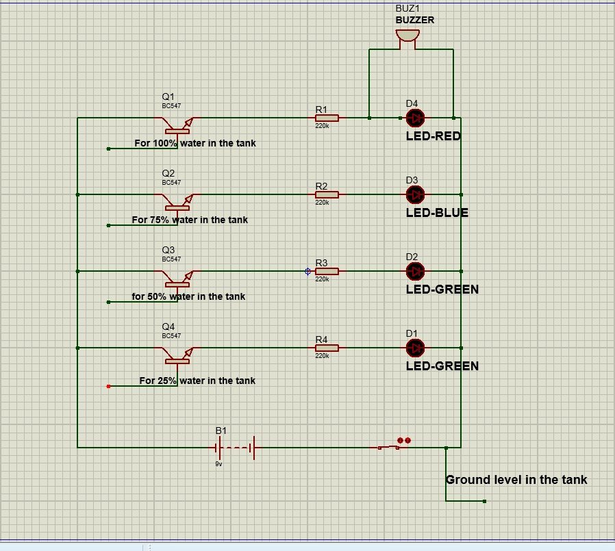

# **WORKING PRINCIPLE**

The water level indicator works on the principle of electrical conductivity. When water meets the wires placed at different levels inside the tank, it completes the circuit, allowing current to flow.

* **25% tank:** When the water level in the tank reaches at 25% of the tank the first led (green) is turned on which indicates water reached the 25% of the tank.
* **50% tank:** When water level reached at 50% of the tank 2 led (green) are on which indicates that water reached at 50% of the tank.
* **75% tank:** When water level reached at 75% of the tank a blue led turned on indicating water level reached at 75% of the tank.
* **Full Tank:** When the tank is full a red led and buzzer turned on indicating tank is full.

# **PROCEDURE**

* We took four copper wires and stripped their ends to act as water sensors.
* Then placed them at different heights in the tank like 25% 50% 75% and full levels.
* Then we connected sensor wire to a transistor.
* Then added resistors to protect the LEDs.
* Then soldered different coloured LEDs (red, blue, green) for each water level.
* Then added a buzzer that beeps when the tank is full.
* Then attached a 9V battery to power everything.
* Then we made sure the ground wire touched the bottom of the tank.
* Now we slowly filled the tank with water.
* Then watched as the LEDs lit up one by one as the water rose.
* We heard the buzzer beep when the tank was completely full.

# **APPLICATIONS**

* Household water tanks to prevent water overflow and wastage.
* Industrial storage tanks monitor liquid level in container.
* Can help agriculture in not wasting water and overflow.

# **Project**

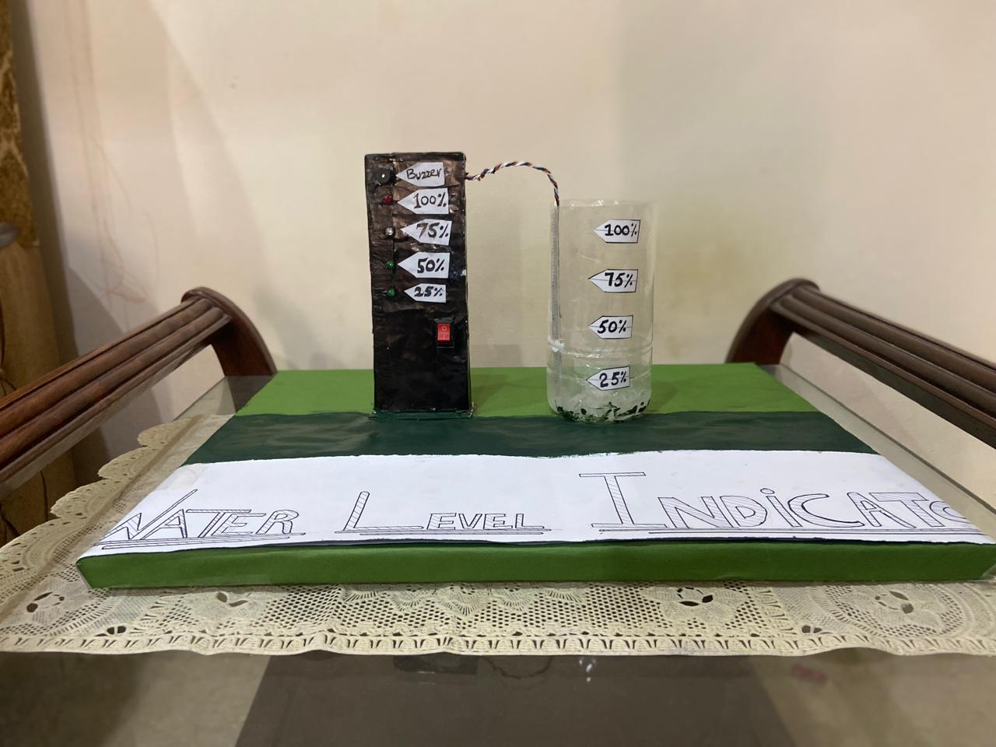

# **CONCLUSION**

This project successfully explained the working of a water level indicator using simple electronic components. It is an efficient, low-cost solution to monitor water levels and prevent wastage. We have built this project just by using wires, 4 led , some transistors and resistor with a buzzer and a battery. This project showed us that even small inventions can solve everyday problems.